NAME:________________________________________

***Clues to Culture***

Watch Video clip #1 <http://www.youtube.com/watch?v=WcEfzHB08QE&feature=related>

Describe one or two of the cultural misunderstandings from clip #1.

________________________________________________________________________________________________________________________________________________________________________________________________________________________________

Why is it important to be aware of cultural differences?

________________________________________________________________________________________________________________

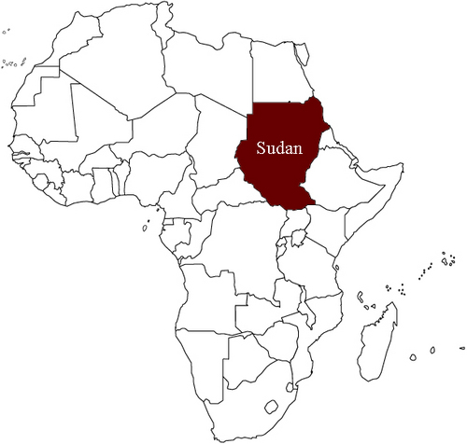

Group Discussion: What do you think are some of the major differences between life in the United States of America and Sudan in Africa?

Watch video clip #2

<http://www.youtube.com/watch?v=BT0kzF4A-WQ&feature=related>

One of the boys expressed that he felt sad by how we treated each other. Explain his feelings.

______________________________________________________________________________________________________________________________________________________________________________________________________

Describe some of the cultural differences that the boys from Sudan experienced in American.

________________________________________________________________________________________________________________________________________________________________________________________________________________________________________________________________________________________________________________________________________________________________________________________________________________________________________________________________________________________________________________________